**CCT College Dublin**

**Assessment Cover Page**

*To be provided separately as a word doc for students to include with every submission*

|  |  |
| --- | --- |
| **Module Title:** | Machine Learning |
| **Assessment Title:** | COVID-19 |
| **Lecturer Name:** | Dr. Muhamad Iqbal |
| **Student Full Name:** | Mijail Fausto Blanco Vargas  Emily Cristina Herbas Luizaga |
| **Student Number:** | 2023012  2023100 |
| **Assessment Due Date:** | 05/11/2023 11:59pm |
| **Date of Submission:** | 03/11/2023 |

**Declaration**

|  |
| --- |
| By submitting this assessment, I confirm that I have read the CCT policy on Academic Misconduct and understand the implications of submitting work that is not my own or does not appropriately reference material taken from a third party or other source. I declare it to be my own work and that all material from third parties has been appropriately referenced. I further confirm that this work has not previously been submitted for assessment by myself or someone else in CCT College Dublin or any other higher education institution. |

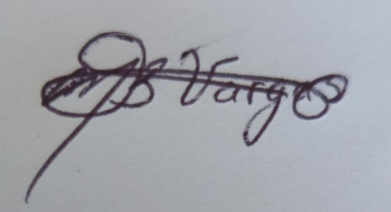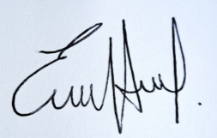

Mijail Blanco Emily Herbas